Date: [Insert date]
Dear [Insert Dr. name],
Re: [Insert child’s name]
DOB: [Insert]
I am writing to you regarding [Insert], as this child’s school-based/community occupational therapist. He/she was seen recently for an occupational therapy consultation, related to school concerns regarding [Insert] (e.g., printing, poor fine motor skills and/or decreased participation in gym).

During the consultation, this child displayed many of the characteristics shown by children with Developmental Coordination Disorder (DCD).

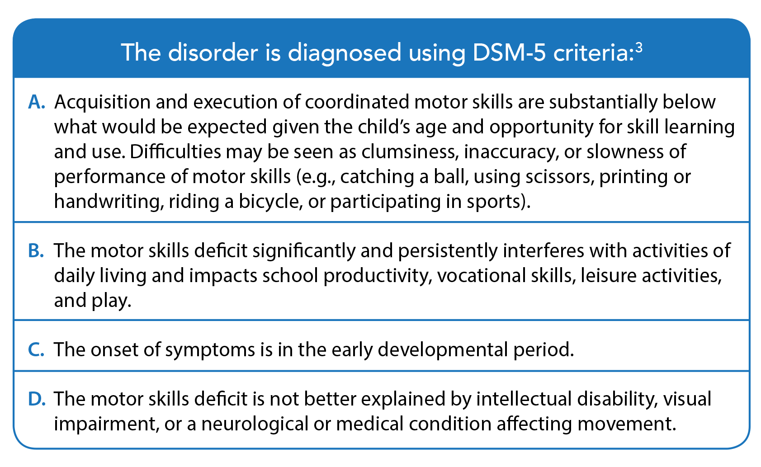
Occupational therapy clinical findings
Best practice for DCD assessment includes an assessment of motor skills by an occupational therapist. Findings from my clinical assessment were as follows: [instructions: enter actual findings below, and delete or replace information that is not relevant]
Criterion A: This child’s motor skills are substantially below that expected given the child’s age and opportunities for skill learning and practice. Standardized testing confirmed that this child is scoring [at or below the 16th percentile OR at or below the 5th percentile for [fine or gross] motor skills (for children 6 years and older) OR at or below the 5th percentile (for those 3-5 years) OR ≤ 5th on manual dexterity or balance, which may be indicative of DCD if all other diagnostic criteria are met].

Criterion B: A screening questionnaire completed by the parents, the Developmental Coordination Disorder Questionnaire (DCDQ), placed the child in the [“indication of DCD” OR “suspected DCD range”].

Criterion C: Parents reported a history of motor difficulties, including [e.g., difficulty in learning age-appropriate motor skills, such as tying shoelaces, riding a bicycle, passing swimming lessons]. The attached “Listening for DCD Checklist”³ may also support assessment of this criterion.
Criterion D: A medical examination is required to rule out other possible explanations for the child’s motor difficulties. Cognitive abilities do not need to be formally assessed (i.e., IQ testing) if there is a normal history of school functioning and academic achievements; however, if any uncertainly exists regarding normal cognitive functioning, standardized testing by a psychologist is recommended.²
Please see attached report for detailed assessment findings.
Next steps
I am writing to you to request further medical consultation to investigate this possible diagnosis of Developmental Coordination Disorder so that the correct supports, adaptations, and appropriate interventions can be put into place both at school and at home.
This diagnostic consideration is needed to avoid the debilitating effects of DCD, which typically impact not only daily living and academic functioning, but also social relationships, participation and psychological issues, including depression and anxiety. Consequently, the quality of life of children and youth with DCD can be considerably compromised. Diagnosis will help the family and school team better understand and advocate for appropriate intervention for their child.
Please do not hesitate to contact me if you have any questions or concerns regarding the above.
Sincerely,

___________________________
[Insert name of occupational therapist and sign above]

References
- American Psychiatric Association. Diagnostic and statistical manual of mental disorders (5th ed.). Arlington, VA. 2013
- Blank R, Smits-Engelsman B, Polatajko H, Wilson P. European Academy for Childhood Disability (EACD): recommendations on the definition, diagnosis, and intervention of developmental coordination disorder (long version). Dev Med Child Neurol. 2012;54:54–93.
- Camden C, Rivard L, Pollock, Missiuna C. Listening for DCD Interview Guide. CanChild. 2013; Available from: http://bit.ly/2Ca1qDw

[Insert address]

[Insert date]

Dear [Insert MLA’s name – use https://www.leg.bc.ca/learn-about-us/members to find your MLA]:

My name is [insert your name] and I am writing to you as your constituent and as an occupational therapist who works with children with Developmental Coordination Disorder (DCD).

DCD is a chronic motor skill disorder seen in children and youth, which significantly affects activities of daily living, school performance, and leisure activities. Children with DCD struggle to learn basic motor tasks, such as doing up zippers and buttons, throwing and catching a ball, printing at school, and learning to swim.

DCD affects ~30,000 children in British Columbia, yet most children do not receive a diagnosis, therapy, or support. This number equates to 1-2 children in every classroom who are affected. If left untreated, children with DCD are likely to experience behaviour problems in school and display low academic performance, poor self-esteem, and mental health problems.

Although DCD is a chronic lifelong condition, the good news is that a little treatment can go a long way. Occupational therapy is effective in helping children with DCD to learn motor skills, to increase their functioning, and to participate and be successful alongside their peers, but intervention for DCD is not yet standard of care. Best practices in DCD treatment lead to measurable improvements in adaptive functioning (e.g., greater independence with self-care activities, improved written output at school, acquisition of motor skills to enable participation in play and leisure activities), which can have a positive effect on the child’s self-esteem and mental health.

I am writing to request your support to ensure funding is available for diagnosis and treatment so that children DCD can experience success and the negative developmental trajectory associated with this disorder can be prevented. I would like to meet with you to discuss solutions to better support children with DCD.
- Improved funding/access to school-based occupational therapists (OTs)
- Funding to enable OTs to provide evidence-based intervention as standard of care (currently only those with access to private funds can afford these treatments)
- Funding for early intervention

I look forward to hearing from you to set up a meeting.

Yours sincerely,

___________________________
[Insert name of occupational therapist and sign above]
Appendix B – Top Tips for Meeting with Elected Officials
Meeting with elected officials and those running for office is a great way for occupational therapists to communicate on important issues. Through these interactions, you can provide valuable education about occupational therapy. Here are a few tips to help you and your audience get the most out of your meeting:

Pre-arranged meeting:
- Be prepared and on time. If you have arranged a meeting with your MLA or a Minister, you will likely have 20-30 minutes at most. Their schedules are very busy, so be prepared and ready to present your information. Bring printed materials with you, but keep them brief and easy to scan/read;
- Dress professionally;
- State your name, profession, and professional affiliation and be sure to identify yourself as a very engaged constituent;
- Make your presentation brief and clear. Select only 1-2 key messages—ask yourself, if they only take-away one thing from your meeting, what would that be? Organize your presentation around those 1-2 key messages; collect information and statistics ahead of time to support your key messages (e.g., gaps in services, incidences, cost/cost-effectiveness, treatment effectiveness, etc.)
- Send additional information that may have been requested.

[Insert address]

[Insert date]

Dear [Insert MLA’s name – use https://www.leg.bc.ca/learn-about-us/members to find your MLA]:

My name is [insert your name] and I am writing to you as your constituent and as parent of a child with Developmental Coordination Disorder (DCD).

DCD is a chronic motor skill disorder seen in children and youth, which significantly affects activities of daily living, school performance, and leisure activities. Children with DCD struggle to learn basic motor tasks, such as doing up zippers and buttons, throwing and catching a ball, printing at school, and learning to swim.

DCD affects ~30,000 children in British Columbia, yet most children do not receive a diagnosis, therapy, or support. This number equates to 1-2 children in every classroom who are affected. If left untreated, children with DCD are likely to experience behaviour problems in school and display low academic performance, poor self-esteem, and mental health problems.

Although DCD is a chronic lifelong condition, the good news is that a little treatment can go a long way. Occupational therapy is effective in helping children with DCD to learn motor skills, to increase their functioning, and to participate and be successful alongside their peers, but intervention for DCD is not yet standard of care. Best practices in DCD treatment lead to measurable improvements in adaptive functioning (e.g., greater independence with self-care activities, improved written output at school, acquisition of motor skills to enable participation in play and leisure activities), which can have a positive effect on the child’s self-esteem and mental health.

I am writing to request your support to ensure funding is available for diagnosis and treatment so that children like my [son/daughter] with DCD can experience success, and so that the negative developmental trajectory associated with this disorder can be prevented. I would like to meet with you to discuss solutions to better support children with DCD.
- Improved funding/access to school-based occupational therapists (OTs)
- Funding to enable OTs to provide evidence-based intervention as standard of care (currently only those with access to private funds can afford these treatments)
- Funding for early intervention

I look forward to hearing from you to set up a meeting.

Yours sincerely,

____________________________
[Insert name of parent and sign above]

Appendix B – Top Tips for Meeting with Elected Officials
Meeting with elected officials and those running for office is a great way for parents, caregivers, and other advocates to communicate on important issues. Through these interactions, you can provide valuable education about occupational therapy. Here are a few tips to help you and your audience get the most out of your meeting:

Pre-arranged meeting:
- Be prepared and on time. If you have arranged a meeting with your MLA or a Minister, you will likely have 20-30 minutes at most. Their schedules are very busy, so be prepared and ready to present your information. Bring printed materials with you, but keep them brief and easy to scan/read;
- Dress professionally;
- Make your presentation brief and clear. Select only 1-2 key messages—ask yourself, if they only take-away one thing from your meeting, what would that be? Organize your presentation around those 1-2 key messages; collect information and statistics ahead of time to support your key messages (e.g., gaps in services, incidences, cost/cost-effectiveness, treatment effectiveness, etc.)
- Send additional information that may have been requested.

[Insert address]

[Insert date]

Dear [Insert MLA’s name – use https://www.leg.bc.ca/learn-about-us/members to find your MLA]:

My name is [insert your name] and I am writing to you as your constituent and as the teacher of a child with Developmental Coordination Disorder (DCD).

DCD is a chronic motor skill disorder seen in children and youth, which significantly affects activities of daily living, school performance, and leisure activities. Children with DCD struggle to learn basic motor tasks, such as doing up zippers and buttons, throwing and catching a ball, printing at school, and learning to swim.

DCD affects ~30,000 children in British Columbia, yet most children do not receive a diagnosis, therapy, or support. This number equates to 1-2 children in every classroom who are affected. If left untreated, children with DCD are likely to experience behaviour problems in school, and display low academic performance, poor self-esteem, and mental health problems.

Although DCD is a chronic lifelong condition, the good news is that a little treatment can go a long way. Occupational therapy helps children with DCD to learn motor skills, to increase their functioning, and to participate and be successful alongside their peers, but intervention for DCD is not yet standard of care. Best practices in DCD treatment lead to measurable improvements in adaptive functioning (e.g., greater independence with self-care activities, improved written output at school, acquisition of motor skills to enable participation in play and leisure activities), which can have a positive effect on the child’s self-esteem and mental health.

I am writing to request your support to ensure funding is available for diagnosis and treatment so that children with DCD can experience success and the negative developmental trajectory associated with this disorder can be prevented. I would like to meet with you to discuss solutions to better support children with DCD.
- Improved funding/access to school-based occupational therapists (OTs)
- Funding to enable OTs to provide evidence-based intervention as standard of care (currently only those with access to private funds can afford these treatments)
- Funding for early intervention

I look forward to hearing from you to set up a meeting.

Yours sincerely,

___________________________
[Insert name of teacher and sign above]
Appendix B – Top Tips for Meeting with Elected Officials

Meeting with elected officials and those running for office is a great way for teachers, parents, and other advocates to communicate on important issues. Through these interactions, you can provide valuable education about occupational therapy. Here are a few tips to help you and your audience get the most out of your meeting:

Pre-arranged meeting:
- Be prepared and on time. If you have arranged a meeting with your MLA or a Minister, you will likely have 20-30 minutes at most. Their schedules are very busy, so be prepared and ready to present your information. Bring printed materials with you, but keep them brief and easy to scan/read;
- Dress professionally;
- State your name, profession, and professional affiliation and be sure to identify yourself as a very engaged constituent;
- Make your presentation brief and clear. Select only 1-2 key messages—ask yourself, if they only take-away one thing from your meeting, what would that be? Organize your presentation around those 1-2 key messages; collect information and statistics ahead of time to support your key messages (e.g., gaps in services, incidences, cost/cost-effectiveness, treatment effectiveness, etc.)
- Send additional information that may have been requested.

